**TO START:**

1. Create a new database named "CompanyDB."

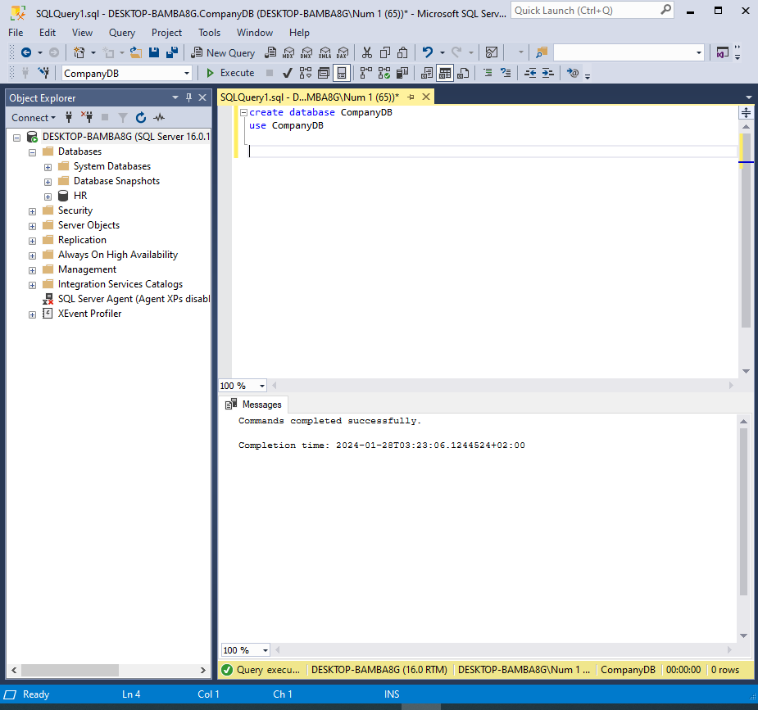

1. Create a schema named "Sales" within the "CompanyDB" database.

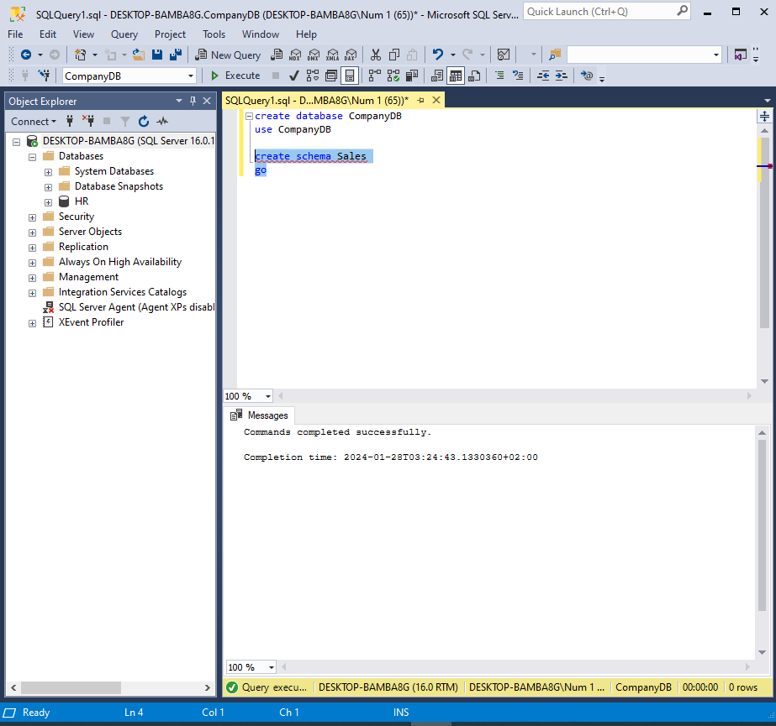

1. Create a table named "employees" with columns: employee_id (INT), first_name (VARCHAR), last_name (VARCHAR), and salary (DECIMAL) within the "Sales" schema.

Note: on employee_id use sequence instead of identity.

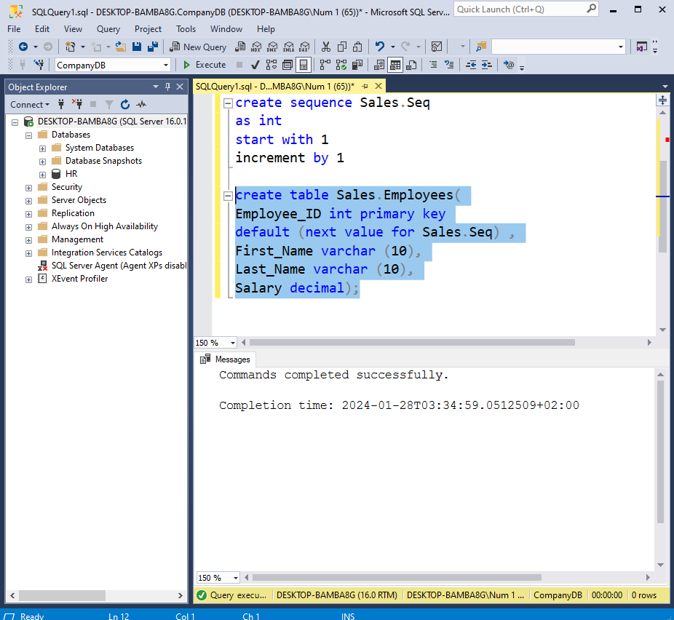

1. Alter the "employees" table to add a new column named "hire_date" with the data type DATE.

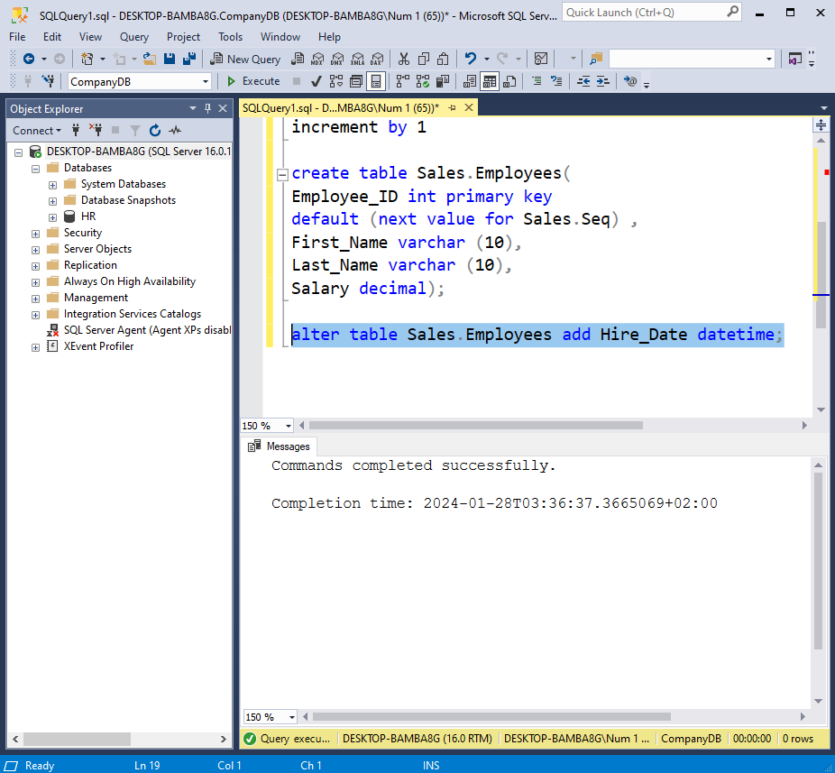

1. Add mock data to this table use <https://www.mockaroo.com>

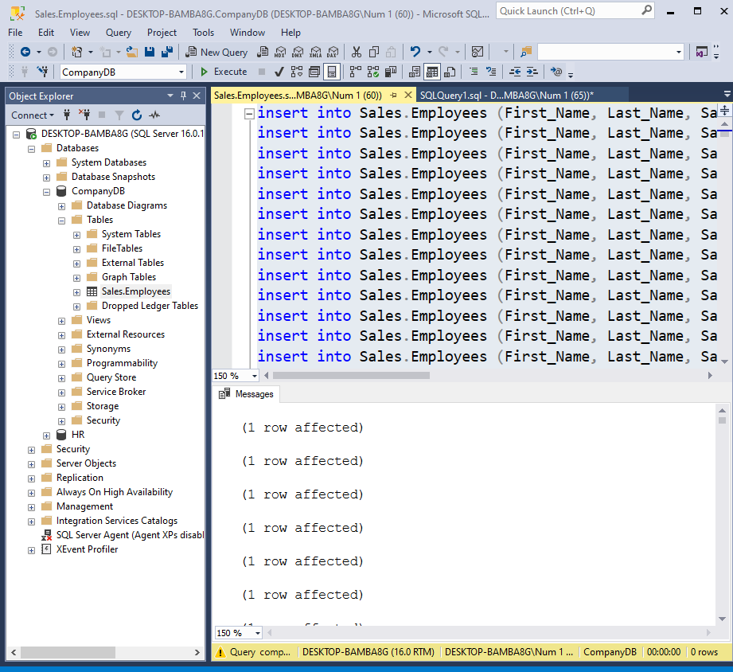

**DATA MANIPULATION Exercises:**

1. Select all columns from the "employees" table.

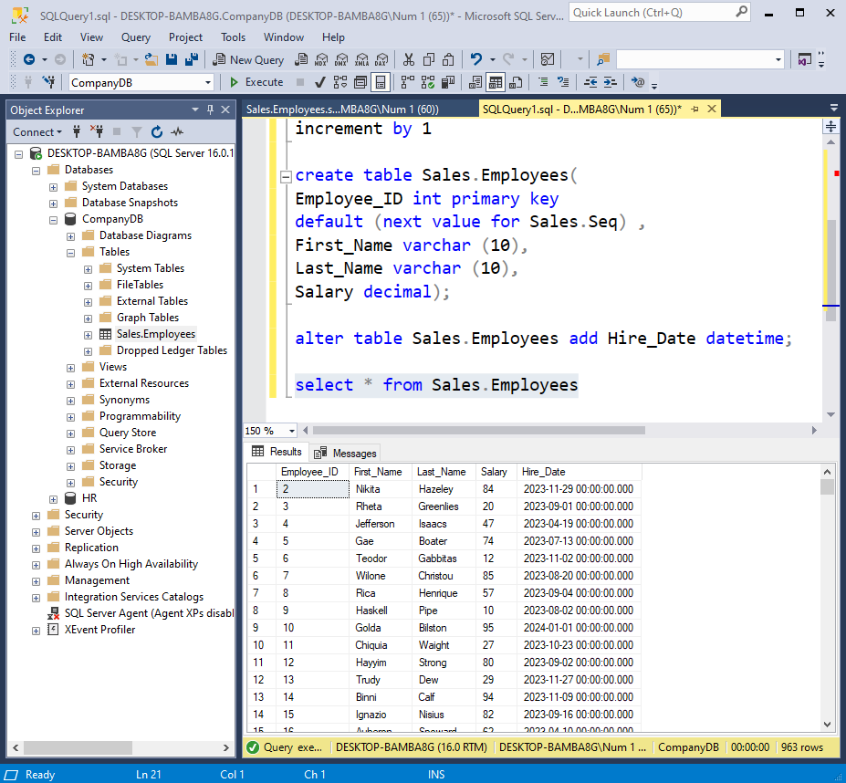

1. Retrieve only the "first_name" and "last_name" columns from the "employees" table.

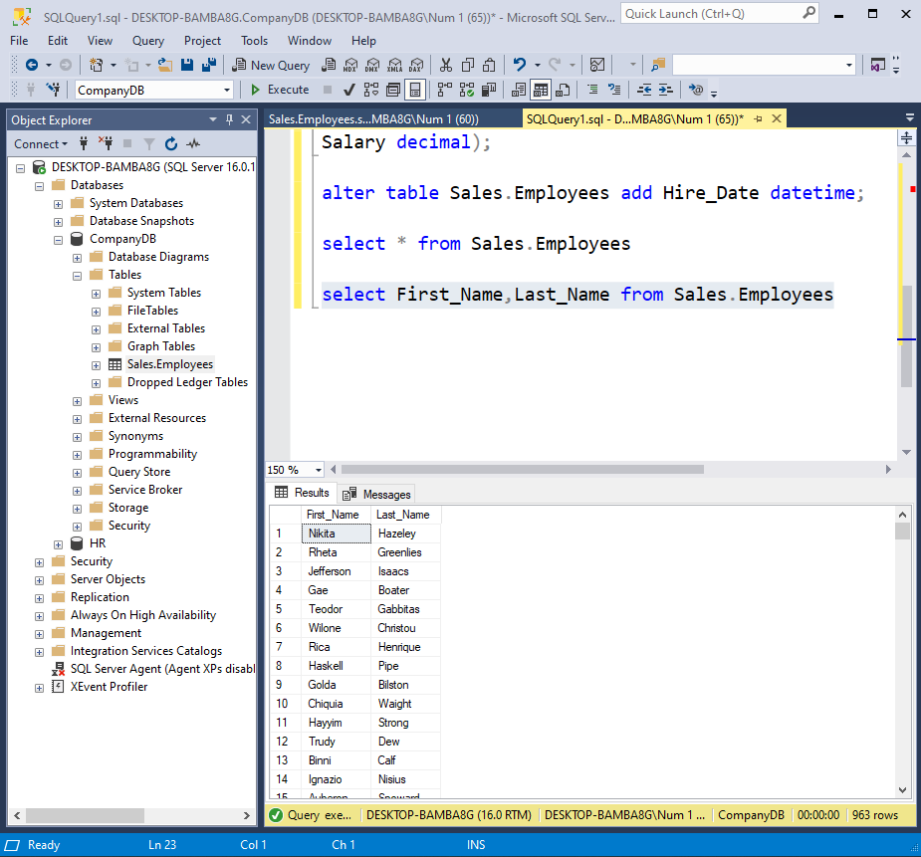

1. Retrieve “full name” as a one column from "first_name" and "last_name" columns from the "employees" table.

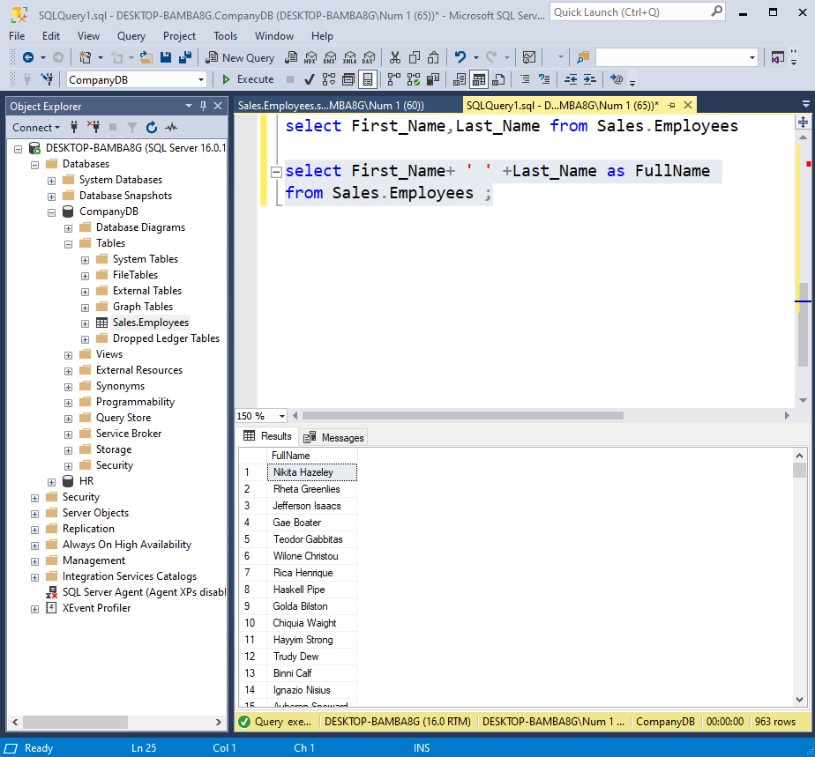

1. Show the average salary of all employees. (search on it, hint: group by)

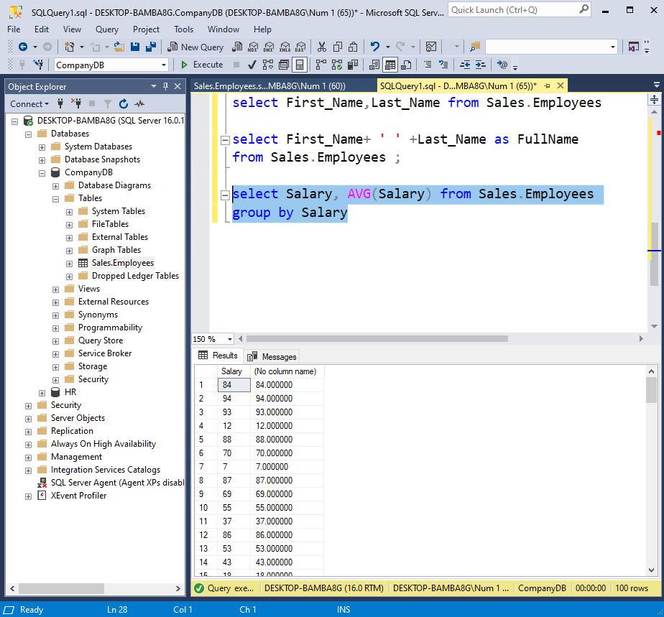

1. Select employees whose salary is greater than 50000.

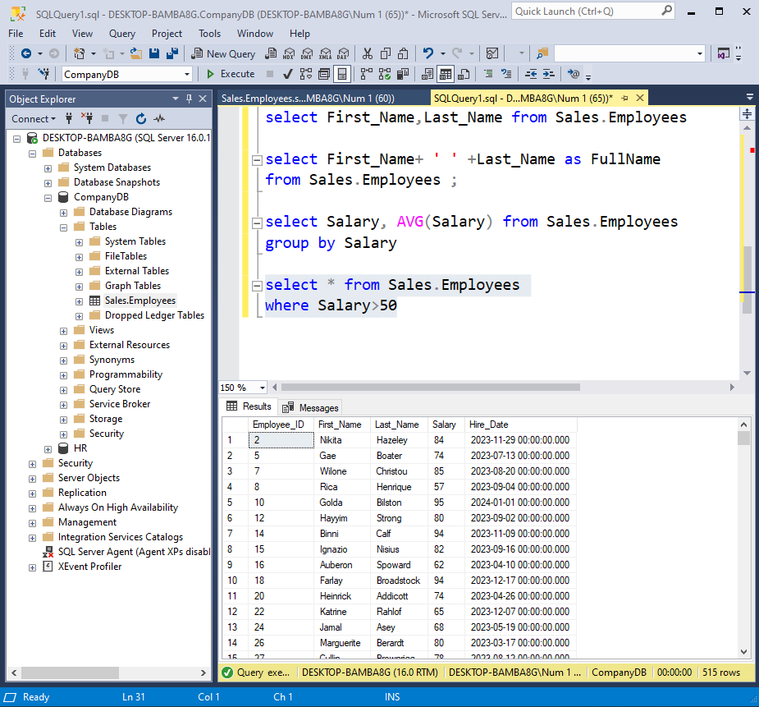

1. Retrieve employees hired in the year 2020.

____________________===========================

1. List employees whose last names start with 'S.'

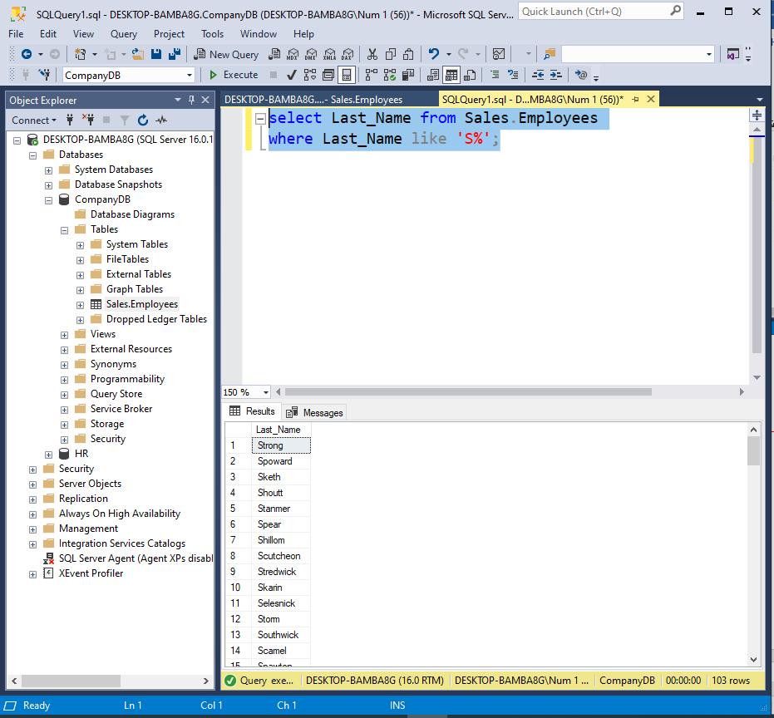

1. Display the top 10 highest-paid employees.

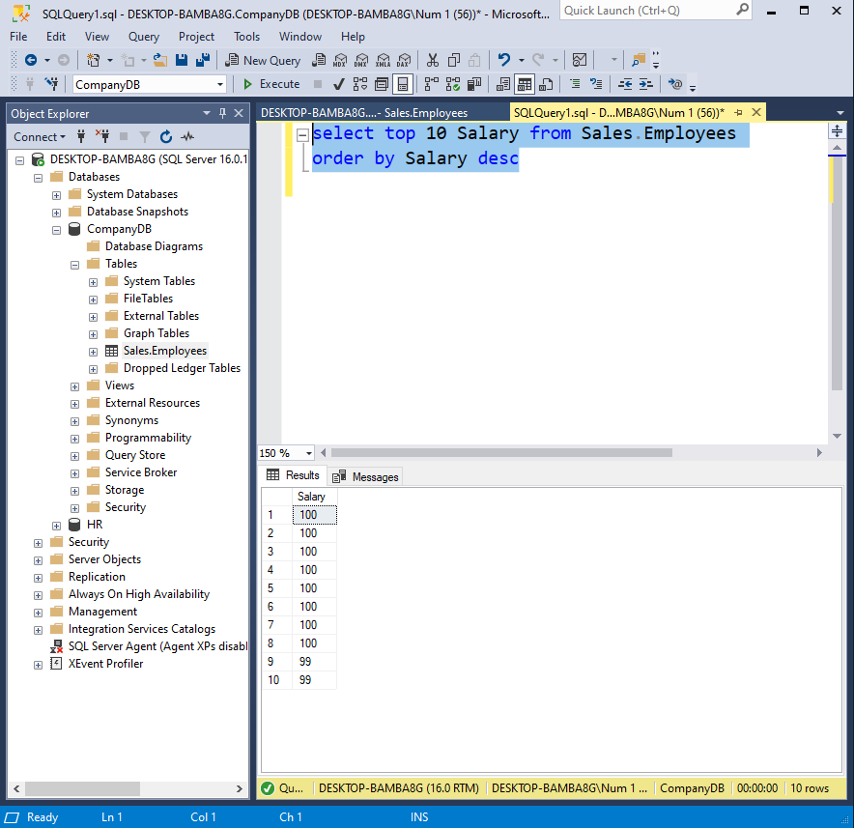

1. Find employees with salaries between 40000 and 60000.

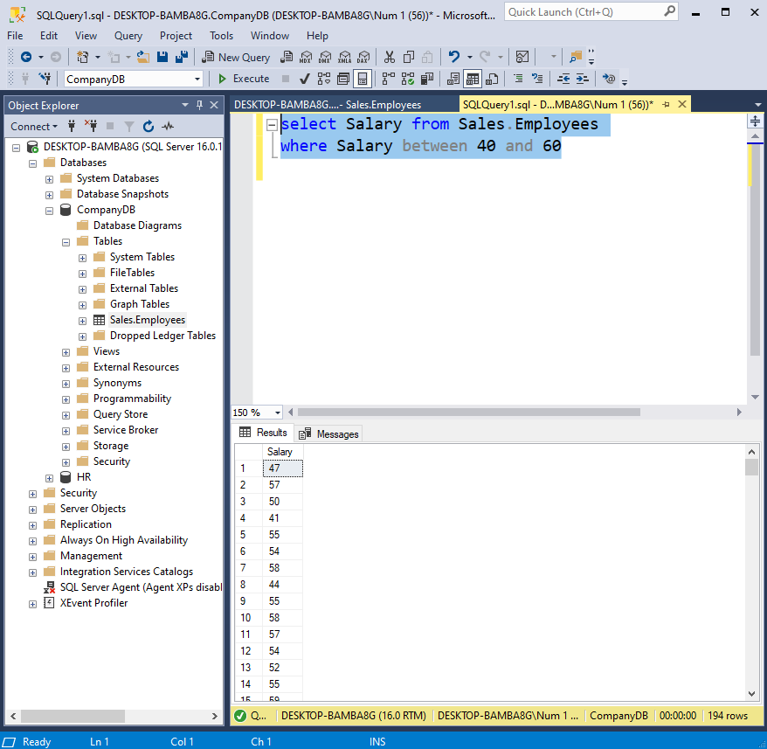

1. Show employees with names containing the substring 'man.'

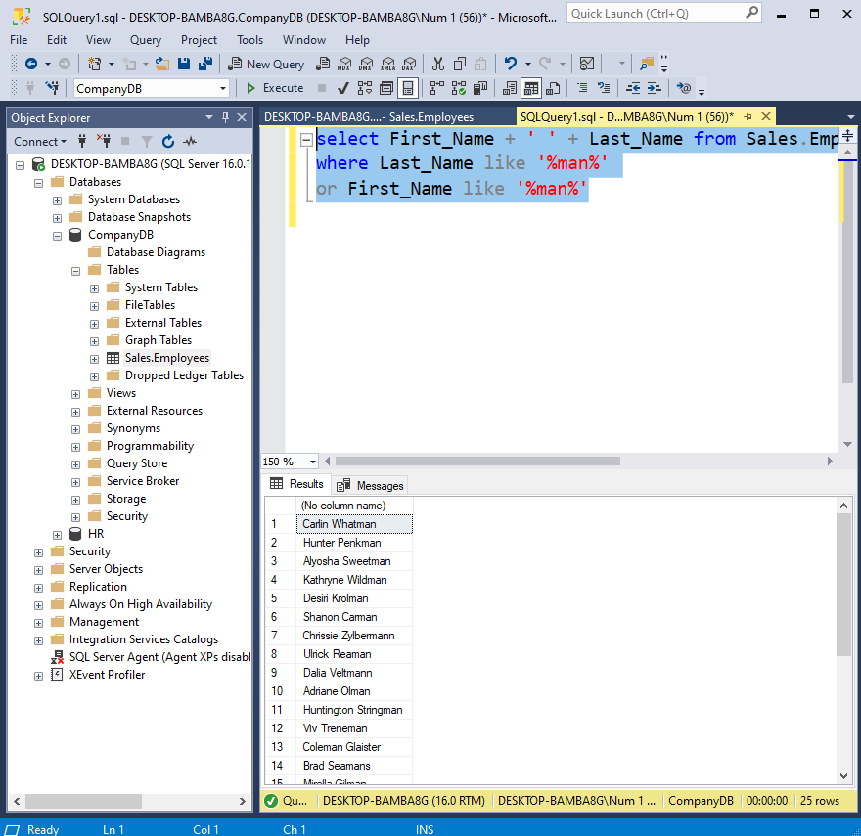

1. Display employees with a NULL value in the "hire_date" column.

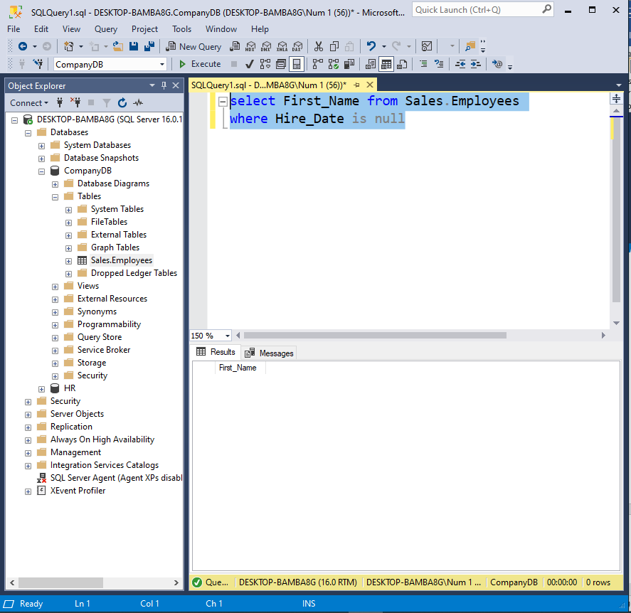

1. Select employees with a salary in the set (40000, 45000, 50000).

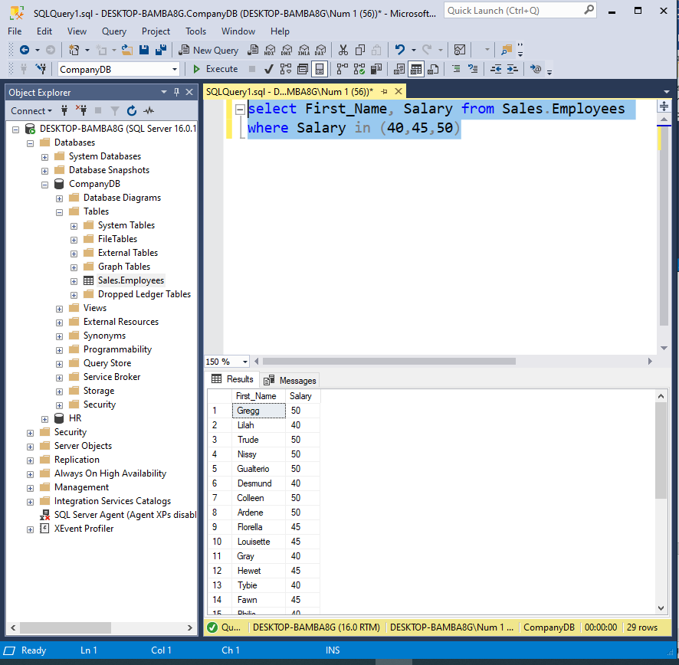

1. Retrieve employees hired between '2020-01-01' and '2021-01-01.'

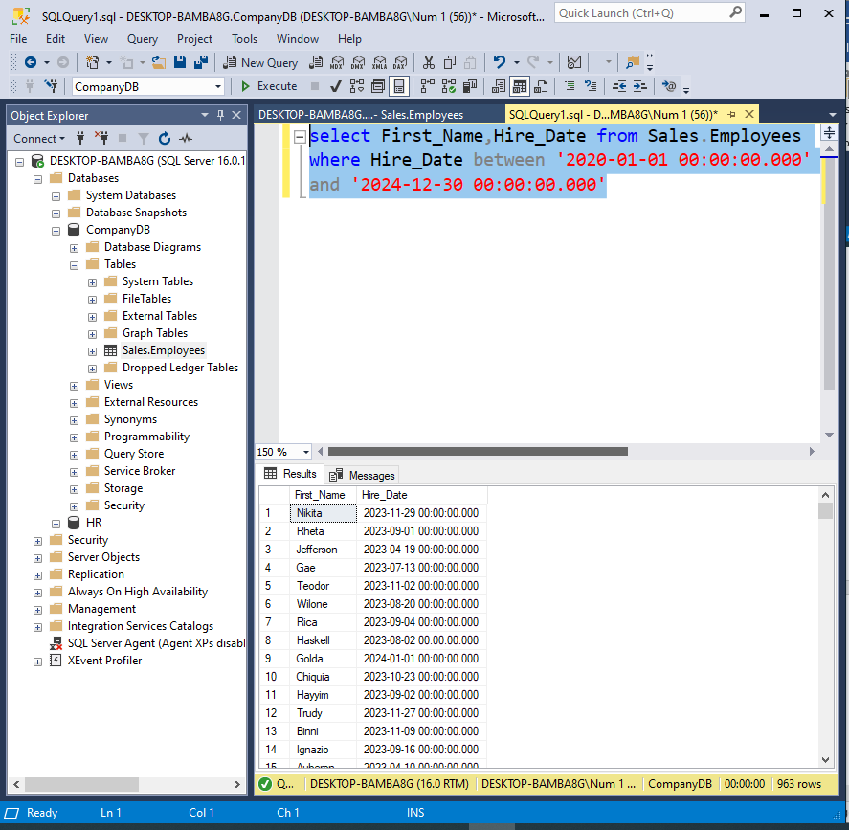

1. List employees with salaries in descending order.

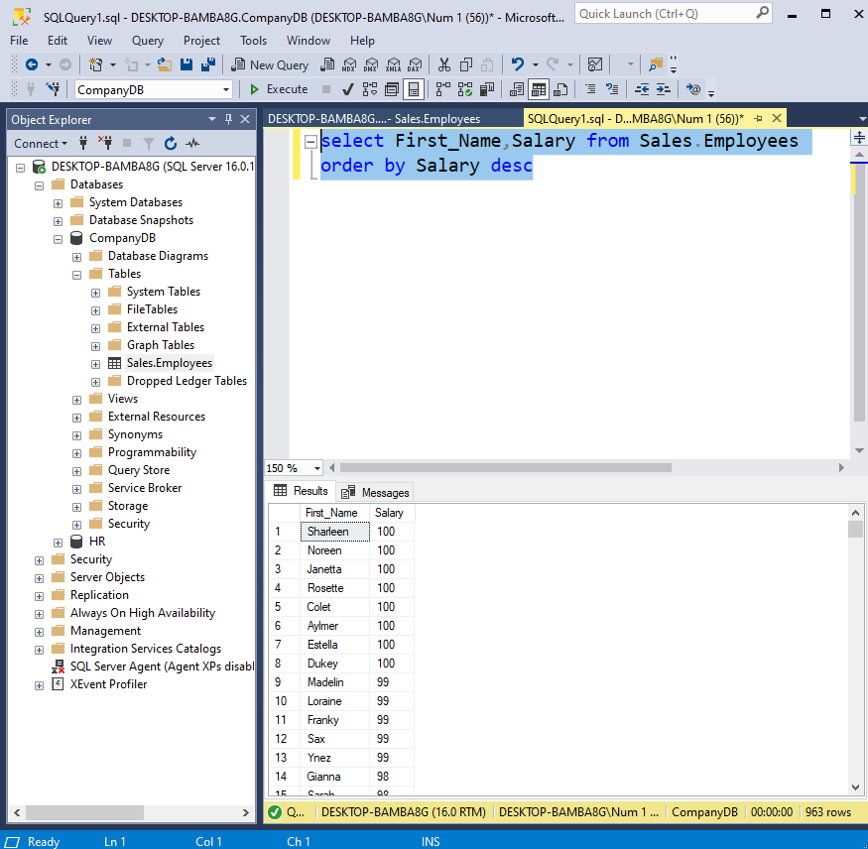

1. Show the first 5 employees ordered by "last_name" in ascending order.

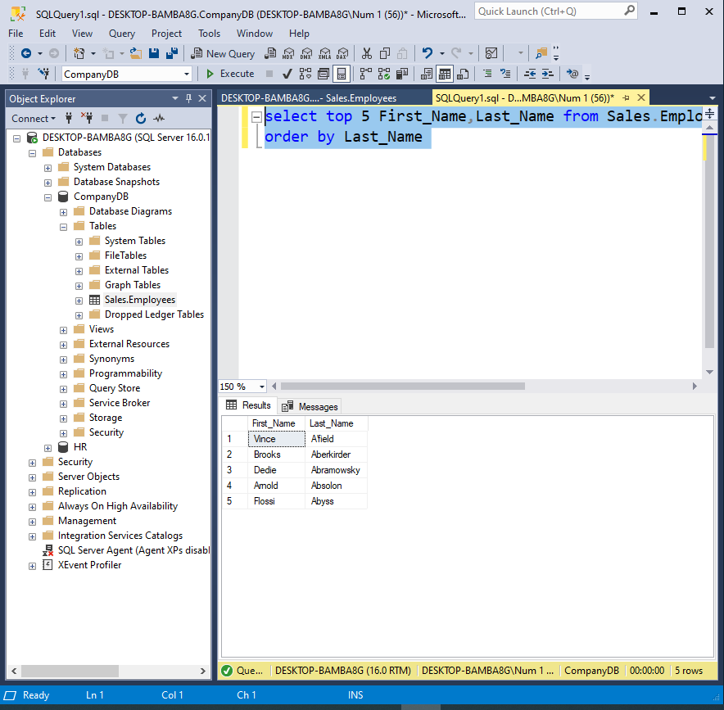

1. Display employees with a salary greater than 55000 and hired in 2020.

-------=======================================================

1. Select employees whose first name is 'John' or 'Jane.'

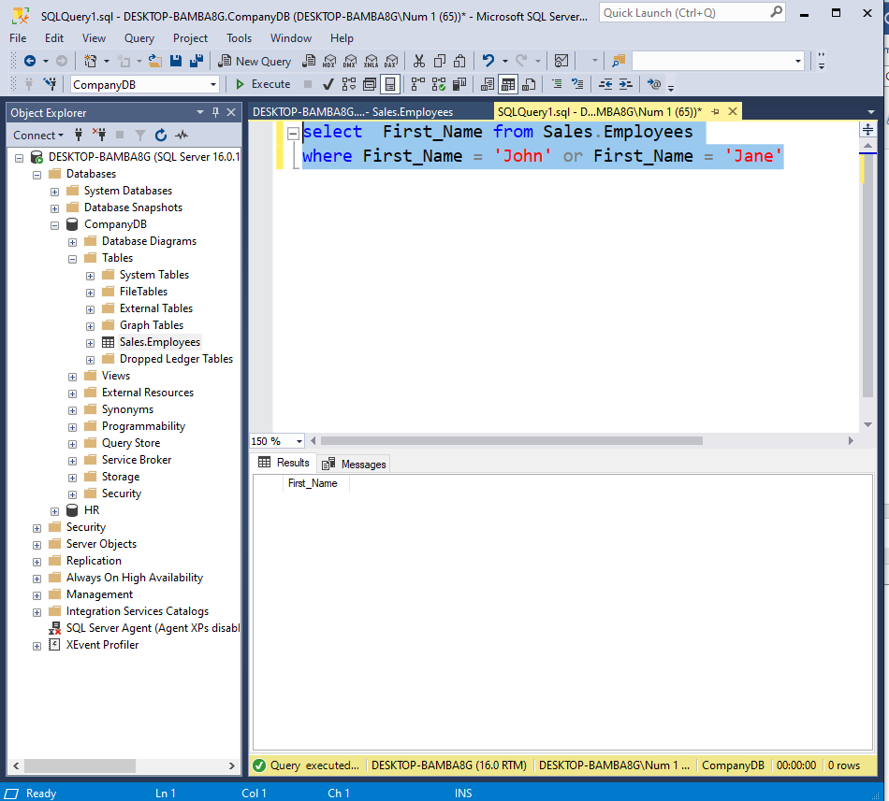

1. List employees with a salary less than or equal to 55000 and a hire date after '2022-01-01.'

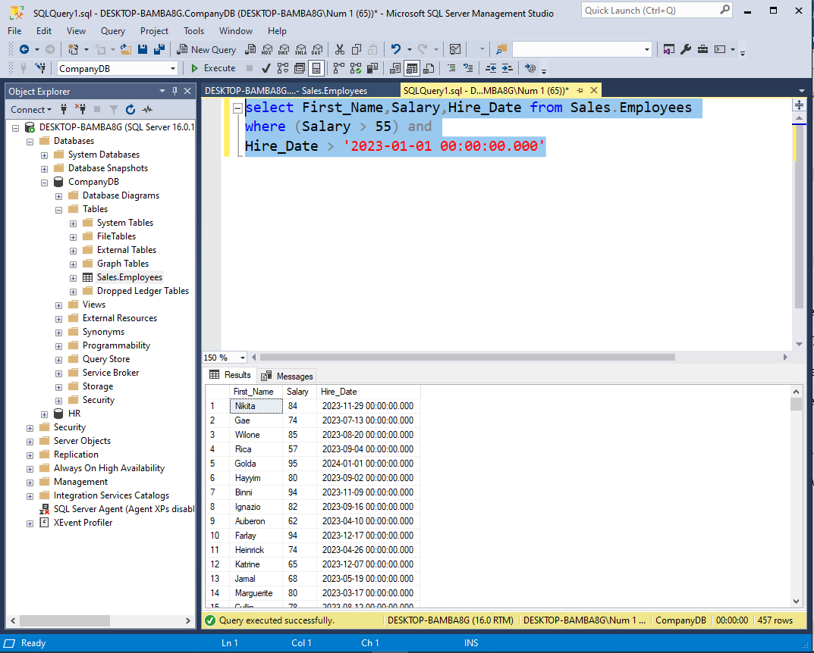

1. Retrieve employees with a salary greater than the average salary.

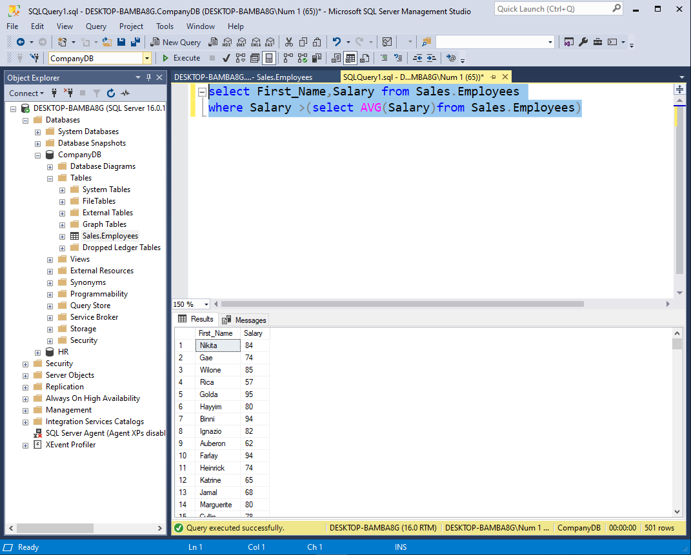

1. Display the 3rd to 7th highest-paid employees. 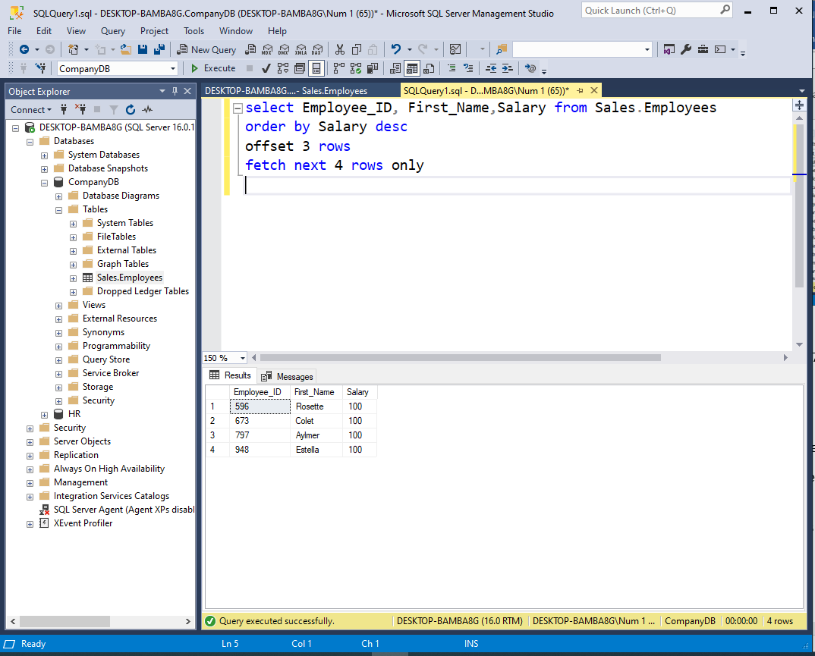
2. List employees hired after '2021-01-01' in alphabetical order.

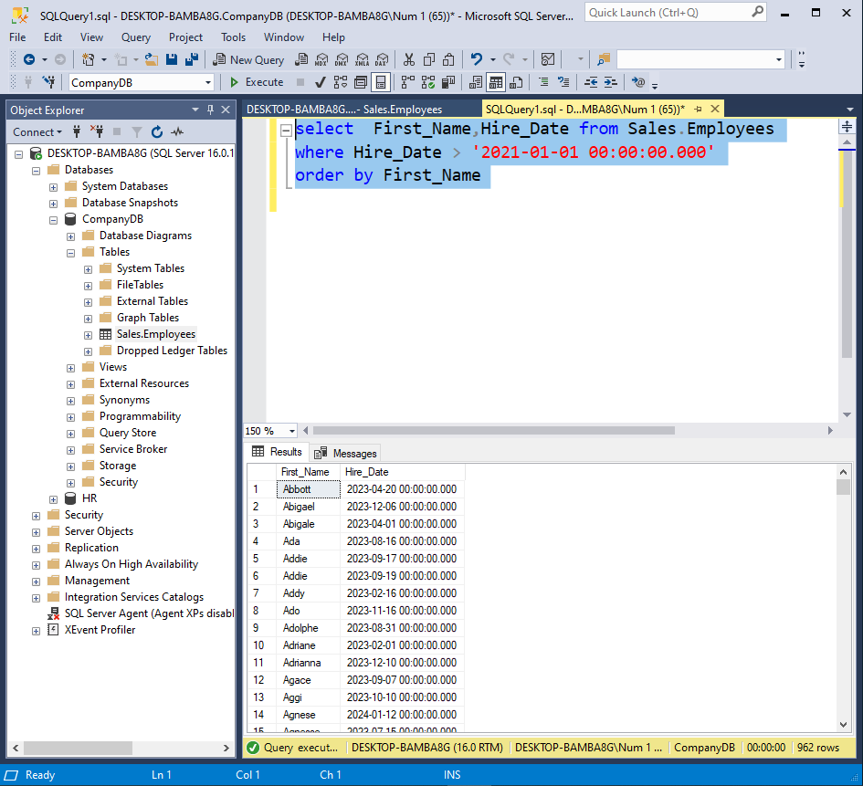

1. Retrieve employees with a salary greater than 50000 and last name not starting with 'A.'

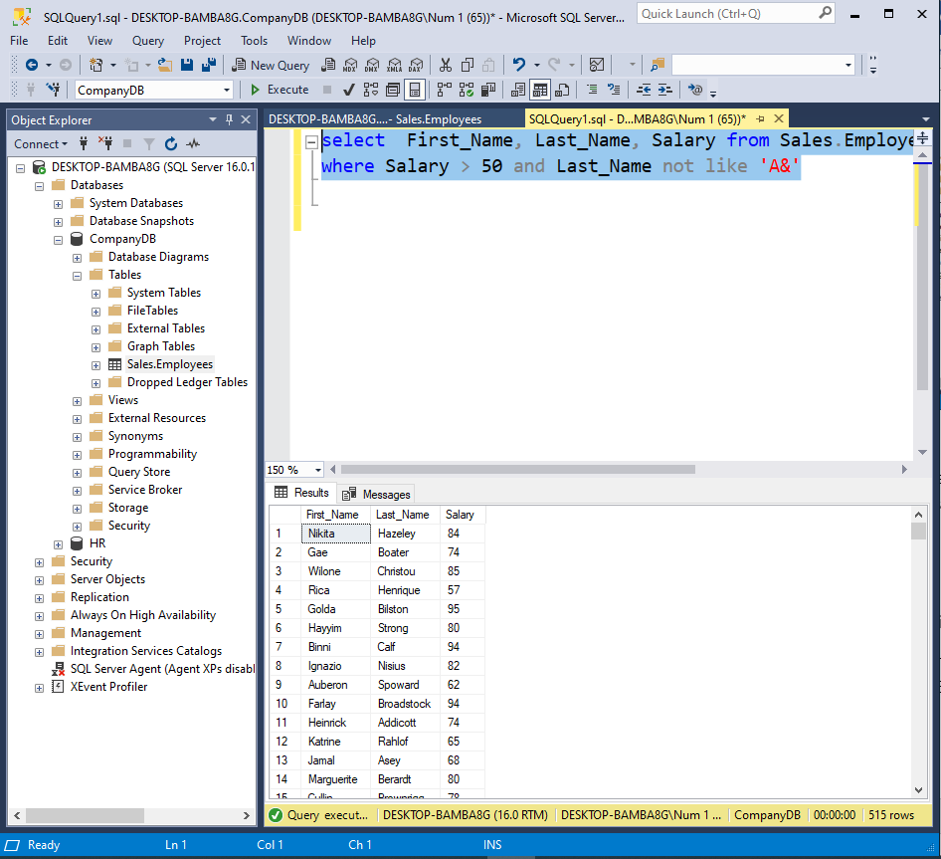

1. Display employees with a salary that is not NULL.

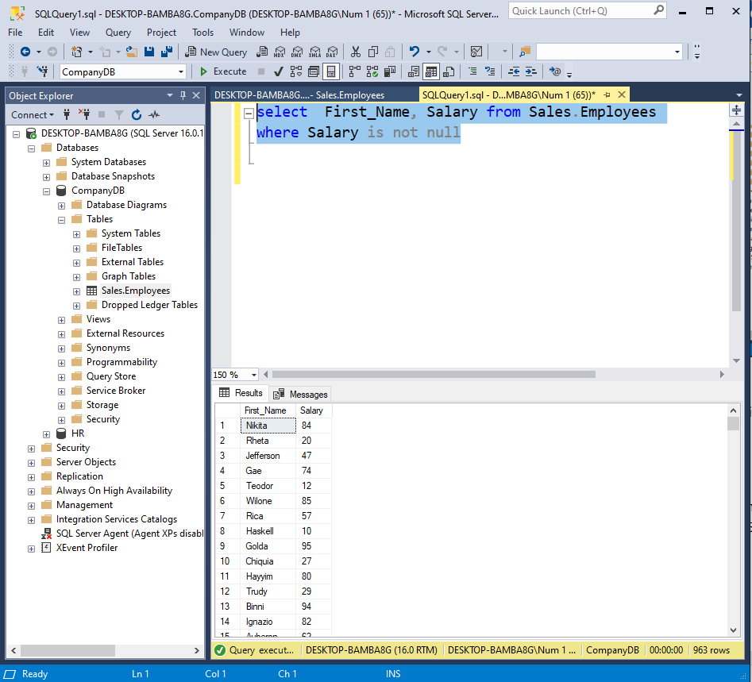

1. Show employees with names containing 'e' or 'i' and a salary greater than 45000.

